**Executive summary**

As a professional Canadian home care agency, ComfortHealth aims to provide high-quality health service while reducing operational costs to make profits. Given the current health center's geolocation planning and health demands in recent years, we can propose different business strategy plans to incorporate the various need of the company and customers. From the proposed model, the company should acknowledge the trade-off between making profits and satisfying demand. In general, satisfying the increasing healthcare demand is costly. The high training/recruiting fee of a certified employee is the main driving force that prevents the company from making a profit in the short term (3 years) if the company wants to satisfy all the immerging health demands. On top of that, the increment in the expense of employment over the years under governmental regulation, comparing to the constant governmental reimbursement, further compressed the company's profitability later in the year. The fundamental issue that the company needs to overcome is the imbalance between the cost of having more health service supply and government funding support.

Our consultant team proposed a sectionalized strategy to satisfy all health demands in designated regions. The company could commit to its service quality and gain a reputation in the targeted area without losing too much profit from distanced regions. Targeting all demand in specific regions also prevents service quality and quantity discrimination.

**Model**

***Demand prediction***

Our model construction starts with demand prediction in 3 years. Based on the Exploratory data analysis result(left), the demand in the past ten years mostly follows a linear pattern.

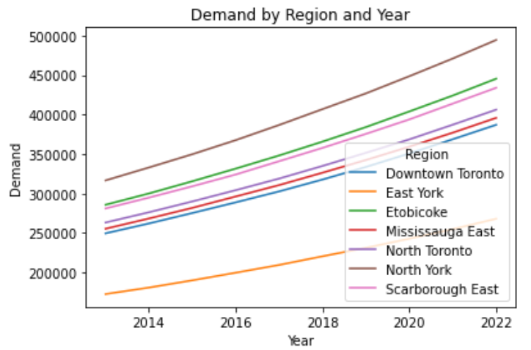 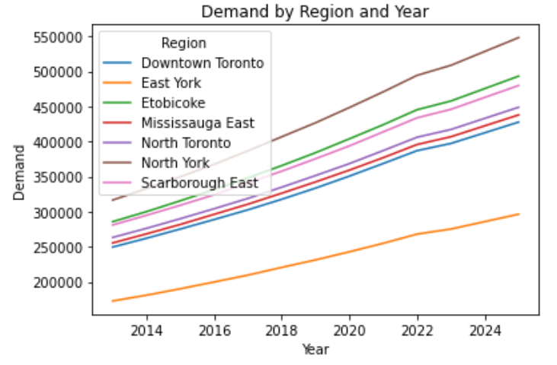

The past data is fitted in a Linear regression model, predicting the demand in 3 years(right). Seven linear models are created based on specific region data, and demand predictions are rounded for simplicity in the later part.

***Model settings***

***(See Appendix 3 math formular)***

***Variable***

There are four variables in the model, namely:

$Y_{ij} :$ Binary variable indicates the operating decision for center j in the year i

$$X_{ijk}: Continuous variable shows the number of service provided from center j to region k in year i$$

$W_{ij}$: Integer variable shows how many HP serves in center j in the year i

$H_{ij}$: integer variable shows how many new HP are hired in center j in the year I

***Constraint***

The constraint is subject to change based on different scenarios, where the company has to decide the amount of health care to accept/reject. The general constraint includes:

The model needs to satisfy either:

Supply & Demand Scenario constraint(1): The service hour must be less than or equal to the total demand (optimizing profit/cost)

Supply & Demand Scenario constraint(2): The service hour must be equal to the certain amount of demand (optimizing the cost to satisfy the demand)

Center capacity constraint: The amount of service hours must be less than the health center limits

HP working capacity constraint: The number of hours allocated to the center must be less than the available HP working hour

HP hiring limits: The headcount (new HPs) limit for each center per year

Center HP association: HP must stay in their assigned(recruited) health center

Open/operating constraint: For new health center, they must be set up before operating

And we are assuming that the new center can and only can open in first year

***Objective:***

The model optimizes the decision variable either:

**Profitable scenario:** The optimal assignment is to maximize the profit over three years, no matter how many clients are served.

**Demand-orientated scenario:** The optimal assignment is to satisfy specific demands, maximizing the profit with needs satisfied.

**Scenario Solution Summary**

Profitable scenario:

                 The optimized solution suggests that: the company should only open Center A, Center B, and Center D and remain the same number of HP (i.e.no, new hiring). The company will use the same strategy for three years. Since no new hiring is suggested, each center's service assignment is always bounded by the available working hours from existing HPs. In addition, the model would always select the closest region to serve to minimize the extra distance cost. The total profit from this scenario is 4110439.6 in 3 years. The trade-off with high yield is the low percentage of health service coverage. Only 23 % of patients are covered in 2023 and 22% in 2024,2025, and only people from certain regions (North York, Scarborough East, Mississauga East) have the chance to get the health care services.

 Demand-orientated scenario (all demands):

                 The model under this scenario would open and operate all health centers in the next three years. In this case, the company must employ new HPs, and due to the limitation in annual hiring, all health centers more or less get some new employees in the first year. In the second year, only center A and Center E hires new HPs, and no HP gets employed in the third year. A total of 1529 new HP will be hired in three years. In Demand orientated scenario, the company can hardly make any profit and lose 13203783.8 instead. The assignment for each HP is still mainly based on the closest distance and assign to other centers only if there are no available HP working hours.

**The model result for scenario 2 shows in appendix 1.**

**Managerial insight**

***HP Hiring***

Hiring new HPs is the only way to serve more people, given that the demand for health care and center capacity is significantly greater than the amount we currently supply.

However, hiring is costly. If we average the training fee over 3 years for a new HP, the extra cost to get a new HP is :

$$Hiring fee / total hour serve(3 year) = 15000/(3yr* 6 hr/day *250day/year) = 3.33\$/hr$$

A new HP in the center without an extra transportation fee would take 37.85+3.33 = 41.18$/hr, close to the government reimbursement of 42$/hr. In addition, if we consider the annual governmental regulation, the cost of one HP in the second year would be 37.85*102.5%+ 3.33 = 42.12$/hr. The company will lose 0.12 per hour in hiring a new HP and more expenses in the third year.

Since we assume that HPs will not leave the center, the earlier we hire, the more time they serve in the health center. The business could hire HP early and make them serve longer to lower hourly costs.

From the hiring table(**See Appendix 1**) of the demand-oriented scenario, we noticed that for high-demand areas like North York, the closest Center (Center A) saturated the training limit in the first year, and more headcounts are needed in the second year. A similar pattern is discovered in the new Center E, which will be discussed later.

***Opening of New center***

Although the total cost (3 years)of having a new health center is cheaper than using old facilities, the shortage in HP is detrimental. As mentioned above, having new HP trained is not worth it if you aim for high profitability. On top of that, a lot of demands remain untouched rounds existing health centers. For a region with high demands (e.g., North York), recruiting new HP in a nearby Health center (Center A) is much prior to opening a new health center.

The lower operation cost in the new facility will show its advantage of lower annual cost in the long term. In fact Center E is a great location to open the health center. It is the only center that is significantly close to both North Toronto and Downtown Toronto. Although these regions have relatively lower demand, transportation from other centers to these regions is at least 2.5/hr higher than Center E.

Thus Center E is a must in longer-term planning if the company wants to address business in North Toronto and Downtown Toronto.

***HP general assignment***

Center A mainly responsible for East and North York. Compared to other cities, the distance between Center A and York city is at least 10km less than the other center; service is only shared to other centers if center A is full of capacity

As the closest center to Scarborough East, center B is the only center that handles demand from Scarborough. Center E shared similar characteristics as center A, which is mainly responsible for Toronto city( **See Appendix 1**)

**Business recommendation**

***Demand rejection/acceptance***

The company needs to find a balance between profitability and demand satisfaction from the previous two scenario models. Based on the current and planning center's location, we recommend scaling up the number of HP in the "local" region (i.e., the distance between the health center and region equal to 0) before expanding their business in other distanced regions. Being a specialty in a certain region with full acceptance of demand helps build the local business brand and reputation in the designated area. On the other hand, localization maintains certain profitability and prevents the business from being a "charity" organization.

             The final suggestion model selects the following cities' Mississauga East',' North Toronto',' North York', 'And Scarborough East' to fully satisfy the healthcare demand and make a total profit of 2255812.7 in three years.

The supply assignment is quite intuitive as the local center(A, B, D, E) will be operated to satisfy the demand from their local region. In year three, instead of hiring more HP in each localized center, the model suggests operating center C with their existing HPs to fill out any left demand from other regions.

The HP working capacity utilization table(**Appendix 2**) shows if HP does not contribute to the service. The cap_difference shows how many hours the center (and HPs) can be allocated if there is a service demand. It is reasonable to have an unused hour in each center that is less than 1500(HP working capacity per person per year).

***Government reimbursement negotiation***

Negotiate with the government to increase the reimbursement to grantee/maintain the quality of service provided. This approach is less viable from the business perspective but provides a more fundamental solution to the generally low profitability issues.

***Confidence in demand variation***

It is hard to capture demand variation in a deterministic model. However, from the past data and our demand prediction model, we can check the variability of our prediction and the actual demands. We may find a distribution for such variance and map with probability density function into our model.

In the deterministic model we proposed, health center C always serves as a backup for a significant demand increase or any outlier demand prediction.

**Appendix 1**

**Center hiring assignment (Scenario analysis model)**

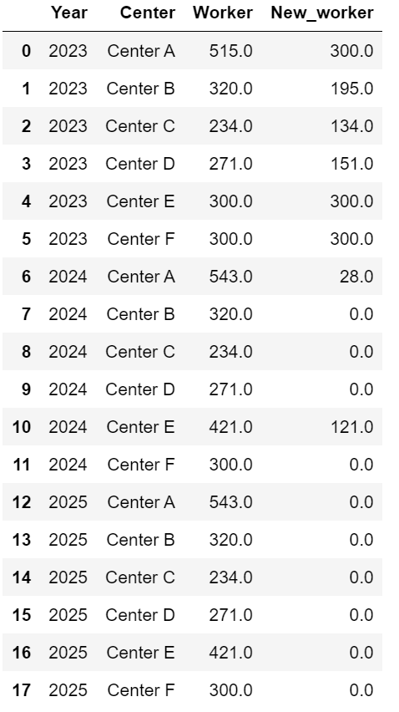

**Center_Region assignment(Scenario analysis model)**

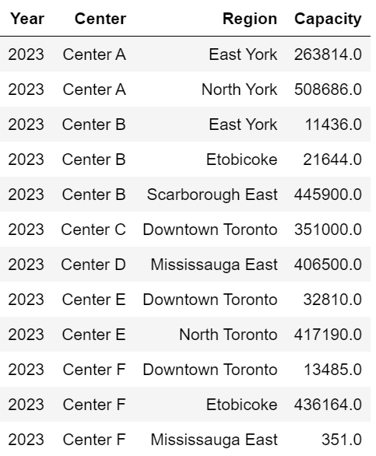 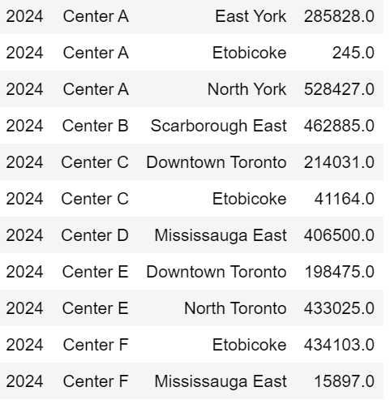 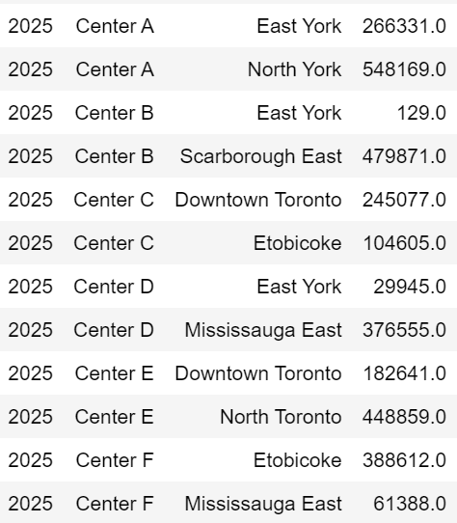

**Appendix 2**

**HP working capacity utilization(Suggested model)**

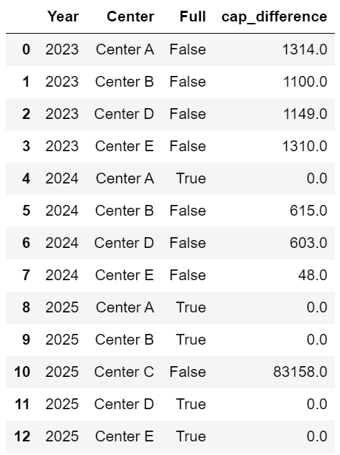

**Center_Region assignment**(**Suggested model) Center hiring assignment (Suggested model )**

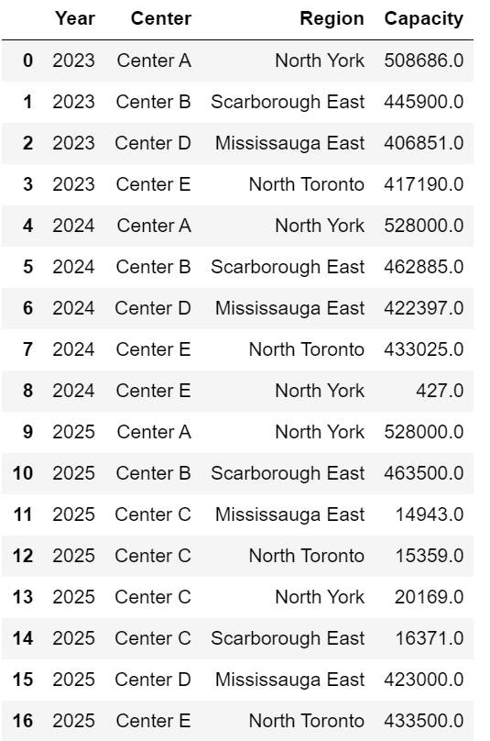 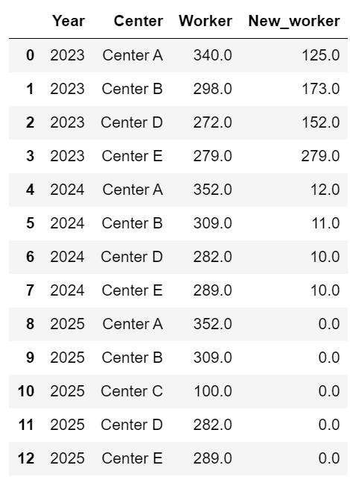

***Appendix 3***

Mathematical model Formular:

Mathematical model

Let assume len(centers) =m; len(regions) = n

$$Max : \sum_{i=2023}^{2025}{\sum_{j=1}^{m}{\sum_{k=1}^{n}{42 X_{ijk}}}}-\sum_{i=2023}^{2025}{\sum_{j =1}^{m}{{operatingCost}_{ij}*}}Y_{ij}$$

$$-\sum_{i=2023}^{2025}{\sum_{j=1}^{m}{\sum_{k=1}^{n}{{(Distance}_{jk}+(({1.025}^{i-2023})*37.85) X_{ijk}}}}-\sum_{i=2023}^{2025}{\sum_{j =1}^{m}{H_{ij}*15000}}$$

S.t.

Scenario constraint(Profitable)

$$\sum_{i=2023}^{2025}{\sum_{j=1}^{m}{\sum_{k=1}^{n}{X_{ijk}==}}}{Demand}_{ij}$$

$$\sum_{i=2023}^{2025}{\sum_{j=1}^{m}{\sum_{k=1}^{n}{X_{ijk}<=}}}{Demand}_{ij}$$

Center capacity constraint:

$$\sum_{i=2023}^{2025}{\sum_{j=1}^{m}{\sum_{k=1}^{n}{ X_{ijk}}}}{<= {Capacity}_{ij} *Y}_{ij}$$

Open/operating constraint

$$Y_{2023_center E}>=Y_{2024_center E}>=Y_{2025_center E}$$

$$Y_{2023_center F}>=Y_{2024_center F}>=Y_{2025_center F}$$

HP working capacity constraint:

$$\sum_{i=2023}^{2025}{\sum_{j=1}^{m}{\sum_{k=1}^{n}{ X_{ijk}}}}<=W_{ij} * 6*250$$

HP hiring limits:

$$H_{ij}≤300for i in \left[2023,2024,2025\right]; j in centers$$

Center HP association:

$$W_{ij}=W_{i-1j}+H_{ij}$$